# Introduction:

* + **Projecttitle:**

**FITFLEX:PhysicalFitnessApp(React)**

* **Teammembers:**
  1. Jagan - Teamleader

[Email -](mailto:Email%20-) romeojagan35@gmail.com

* 1. R.Kishore kumar - Speaker about the project

Email - rkishorekumar372@gmail.com

* 1. S.Prithviraj - Documentcreator

Email - svprithviraj92@gmail.com

* 1. V.Prakash - Takingnotesabouttheproject

[Email - prakash1472005](mailto:Email-Prathiba.v.25.bsccs@princeshribalaji.in) @gmail.com

# Projectoverview:

* + **Purpose**:

Fitnessapplicationistoassistusersinachieving their health and fitness goals by providing tools, guidance, and motivation. Here are some key purposes features of fitness applications.

* + 1. TrackingProgress
    2. Personalized Workouts
    3. NutritionGuidance
    4. MotivationandAccountability
    5. EducationandResources

## Featuresoffitness-app:

1. **PromoteHealthandWell-being**

* Encourage users to maintain an **active lifestyle** by providing structured workout
* Educateusersabout**exercisebenefits,nutrition,andoverallfitness**.
  + Helpreducetherisksofsedentarybehavior,obesity,andlifestyle- related diseases.

## ProvidePersonalizedFitnessPlans

* Customizeworkoutsbasedon**userpreferences,fitnesslevels,andgoals**.
* Use **AI-driven recommendations** to suggest exercises and track progress.
* Allowuserstoset**goals**(e.g.,weightloss,musclegain,endurancetraining).

## ImproveWorkoutEfficiency

* Providestructured**exerciselibraries**withproperinstructionsand visuals.
* Allowusersto**logworkouts,tracksets,reps,andprogress**overtime.
* Offer **real-time guidance** using videos, GIFs, or step-by-step instructions.

## ProvideDataAnalytics&ProgressTracking

* Usechartsandgraphstoshow**caloriesburned,weightprogress**.
  + Offer**AI-driveninsights**tosuggestimprovementsinworkoutroutines.
  + Helpusers**comparepastandpresentperformance**formotivation
* ActivityTracking
* Nutritiontracking
* Motivationaltools

# Architecture:

### Components Structure:

src/

* │──assets/ #Storesstaticfileslikeimagesand styles
* │── **components**/ #ContainsreusableReactcomponents
* │──About.jsx #Aboutsection
* │──Footer.jsx #Websitefooter
* │──Hero.jsx #Mainhero/bannersection
* │──HomeSearch.jsx#Searchfunctionalitforhomepage
* │──Navbar.jsx #Navigationbar
  1. About.jsx
  2. Footer.jsx
  3. Hero.jsx
  4. Homesearch.jsx

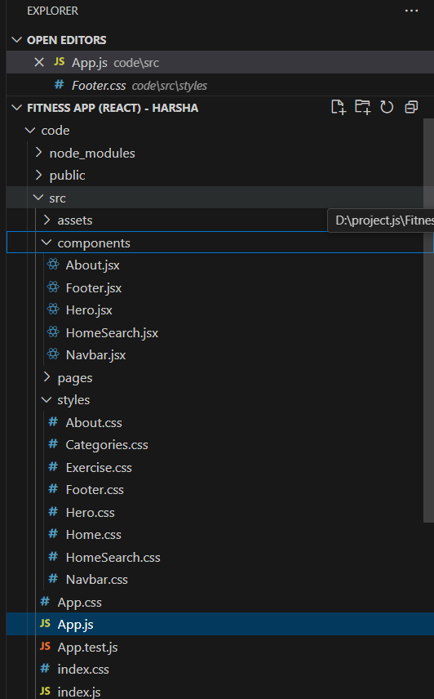

## Routing:

* Setuptheclearroutingpathstoaccessvariousfilesinthe application**.**
* DeveloptheNavbarandHerocomponents
* Codethepopularsearch/categoriescomponentsandfetch the categories from rapid Api.
* Additionally,wecanaddthecomponenttosubscribeforthe newsletter and the footer.
* Now,developthecategorypagetodisplayvariousexercises under the category.
* Finally,codetheexercisepage,wheretheinstructions,other details along with related videos from the YouTube will be displayed.

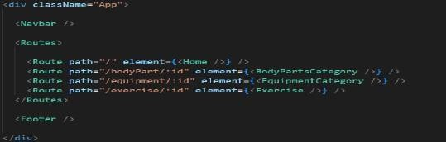

## SetupInstructions:

**Pre-requisites:**

* Herearethekeyprerequisitesfordevelopinga frontend application using React.js:
  1. Node.jsandnpm
  2. React.js
  3. Html,cssandjavascript
  4. Visualstudio code

## Installation:

### ✔Node.jsandnpm:

Node.jsisapowerfulJavaScriptruntimeenvironmentthatallows youtorunJavaScriptcodeonthelocalenvironment.Itprovidesa scalableandefficientplatformforbuildingnetworkapplications. Install Node.js and npm on your development machine, as they are required to run JavaScript on the server-side.

* Download:https://nodejs.org/en/downld/
* Installation:https://nodejs.org/en/download/package- manager/

### ✔React.js:

React.js is a popular JavaScript library for building user interfaces. It enables developers to create interactive and reusableUIcomponents,makingiteasiertobuilddynamicand responsive web applications.

InstallReact.js,aJavaScriptlibraryforbuildinguserinterfaces.

* + CreateanewReactapp:

npxcreate-react-appmy-react-app

* + Navigatetotheprojectdirectory: cd my-react-app
  + RunningtheReactApp:

With the React appcreated, you cannow start the developmentserverandseeyourReactapplicationinaction.

* + Startthedevelopmentserver: npm start

This command launches the development server, and you canaccessyourReactappat[http://localhost:3000](http://localhost:3000/)inyour web browser.

✔**HTML,CSS,andJavaScript:**BasicknowledgeofHTMLfor creating the structure of your app, CSS for styling, and JavaScript for client-side interactivity is essential.

✔ **Version Control:** Use Git for version control, enabling collaboration and tracking changes throughout the developmentprocess.PlatformslikeGitHuborBitbucketcan host your repository.

* + - Git:Downloadandinstallationinstructionscanbe found at: <https://git-scm.com/downloads>

✔ **Development Environment:** Choose a code editor or IntegratedDevelopmentEnvironment(IDE)thatsuitsyour preferences, such as Visual Studio Code, Sublime Text, or WebStorm.

* + - VisualStudioCode:Downloadfrom https://code.visualstudio.com/download

### Folderstructure:

fitness-app/

│──node_modules/ #Installednpmpackages

│──public/ #Staticassetslikeimages,icons,andmanifestfiles

│──src/ #Mainsourcecode directory

│ │──assets/ #Storesimages,logos,videos,andstyles

│ │──components/ #ReusableUI components

│ │ │──Navbar.jsx #Navigationbar

│ │ │──Footer.jsx #Footersection

│ │ │──SearchBar.jsx #Searchinputforexercises

│ │ │──ExerciseCard.jsx#Displaysindividualexercises

│ │ │──Loader.jsx #Loadingspinnercomponent

│ │──pages/ #Containsdifferentpagesoftheapplication

│ │ │──Home.jsx #Landingpagewithfeaturedworkouts

│ │ │──Exercise.jsx #Detailedexercisepage

│ │ │──BodyPartsCategory.jsx#Listsexercisesbybody part

│ │ │──EquipmentCategory.jsx#Listsexercisesbyequipment

│ │──utils/ #UtilityfunctionslikeAPIcalls

│ │ │──fetchData.js #FetchesdatafromAPI

│ │──App.js #Maincomponent,definesroutes

│ │──index.js #Entrypoint,rendersAppcomponent

│──.env #Environmentvariables(APIkeys)

│──package.json #Projectmetadataanddependencies

│──README.md #Projectdocumentation

* Client:

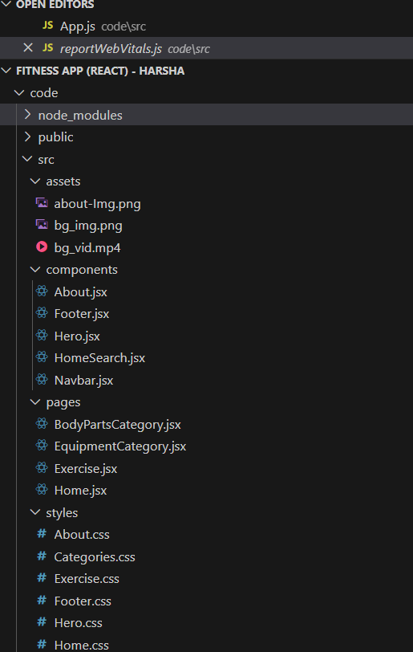

## runningtheapplication:

* Tostartthedevelopmentserver, execute the following command:

npmstart

AccesstheApp:

* Openyourwebbrowserandnavigate to [http://localhost:3000.](http://localhost:3000/)
* You should see the application's homepage,indicatingthattheinstallationandsetup were successful.

### componentsdocumentation:

**Keycomponents:**

Typicalcomponentsofafitnessapp documentation:

* FunctionalRequirements
* Technical Requirements
* UserInterface(UI)andUserExperience(UX) Features and Functionality
* IntegrationandAPIDocumentation
* TestingandQualityAssurance
* DeploymentandMaintenance
* SecurityandCompliance
* GlossaryandReferences

### Reusablecomponents:

* + WorkoutModule
  + NutritionModule
  + ProgressModule
  + CommunityModule
  + UserProfileModule

### statementmanagement:

**GlobalState:**

Globalstatereferstothesharedstatethat isaccessiblethroughout theapp.Inafitness app,globalstate might include:

1. **UserProfile:**Userinformation,suchasname,email, weight, height, and fitness goals.
2. **WorkoutHistory:**Arecordofallworkoutscompleted by the user.
3. **Progress Tracking:** User progress, including metrics suchasweight,bodyfatpercentage,andworkoutfrequency.
4. **Settings:**Appsettings,suchasunitsofmeasurement, language, and notification preferences**.**

### LocalState:

Effectivelocalstatemanagementiscrucial

forafitnessapp,asitenables:

1. **ImprovedUserExperience:**Localstatemanagement enables a seamless and responsive user experience.
2. **ReducedBugs:**Properlocalstatemanagementreduces the likelihood of bugs and errors.
3. **EasierDebugging:**Localstatemanagementmakesit easier to debug and identify issues.
4. **Improved Code Organization:** Local state managementpromotescodeorganizationandseparationof concerns.

## userinterface:

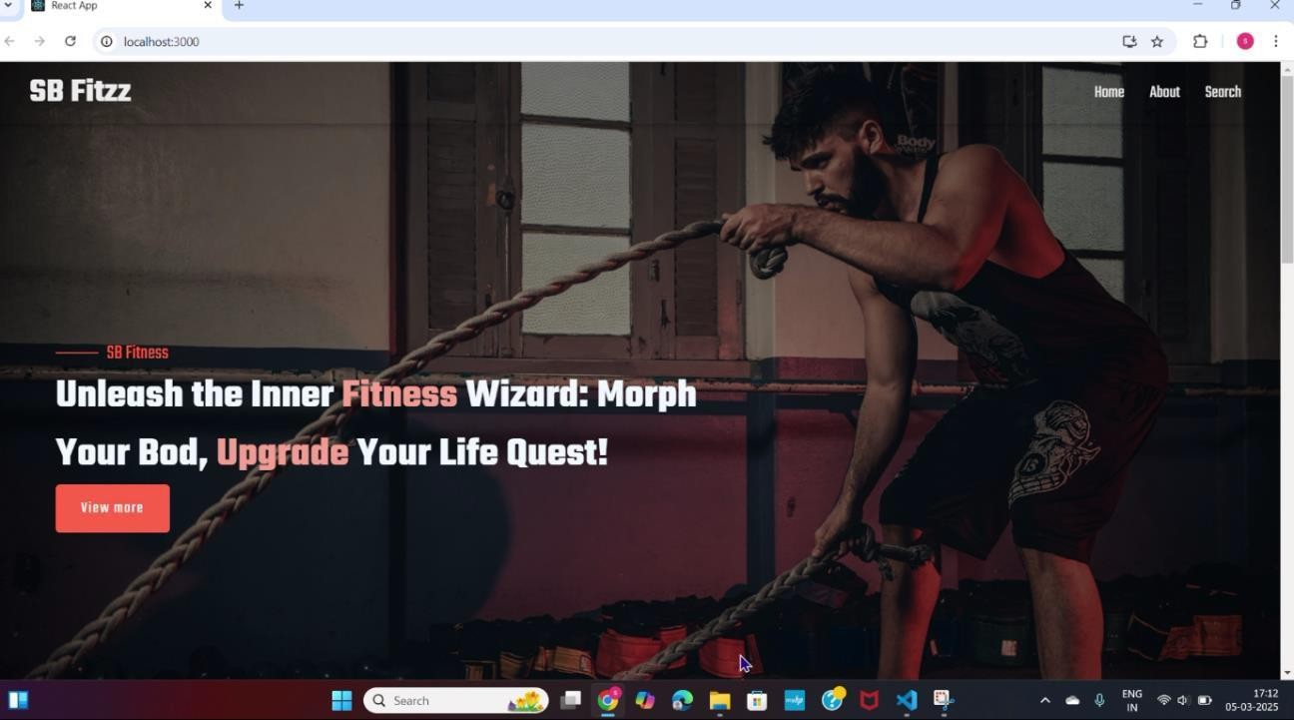

1. styling:

### CSSFrameworksandLibraries:

CSSframeworks andlibrariesprovide pre-built

CSSclassesandcomponentstospeedupdevelopmentand improve consistency. Some popular options include:

* + Bootstrap:Awidely-usedframeworkforbuilding responsive, mobile-first UI components.

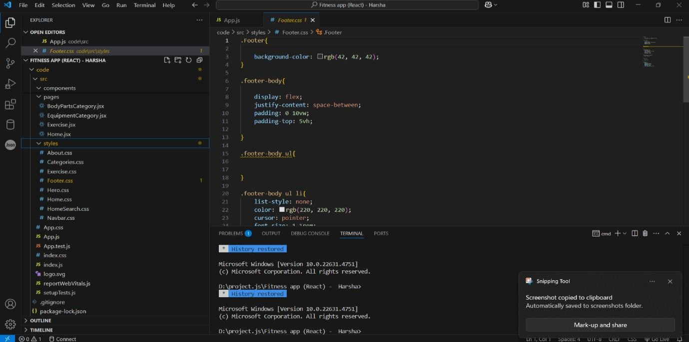

Theming

Theming involves customizing the visual appearance of an applicationtomatchaspecificbrandorstyle.Themingcanbe achieved through:

1. CSSVariables:UsingCSSvariablestodefine theme-related values, such as colors and typography.
2. Preprocessors:UsingpreprocessorslikeSass or Less to define themes and generate CSS.
3. ThemeSwitching:Implementingtheme switchingtoallowuserstoswitchbetween different themes.

# Testing:

**Testingstrategy:**

1. **UnitTesting:**Testindividualcomponents,such as workout tracking and nutrition planning.
2. **IntegrationTesting:**Testhowdifferent components interact with each other.
3. **SystemTesting:**Testtheentireapp,including all features and functionality.
4. **AcceptanceTesting:**Testtheapptoensureit meets the requirements and specifications.
5. **Usability Testing:** Test the app's user experience,includingnavigation,layout,andoverallusability.
6. **Performance Testing:** Test the app's performance,includingloadtesting,stresstesting,andscalability testing.
7. **Security Testing:** Test the app's security, includingauthentication,authorization,anddataencryption.

## objectives:

1. EnsureFunctionality
2. IdentifyBugs
3. ValidateUserExperience
4. CheckPerformance

# Codecoverage:

Codecoverageisameasureofhowmuchofthe code isexecuted duringtesting. It helps ensure thatthe code is thoroughly tested and that there are no gaps in testing.

* 1. **StatementCoverage:**Measuresthepercentageof statements executed during testing.
  2. **DecisionCoverage:**Measuresthepercentageofdecision points (e.g., if-else statements) executed during testing.
  3. **BranchCoverage:**Measuresthepercentageofbranches (e.g., true or false) executed during testing.
  4. **FunctionCoverage:**Measuresthepercentageof functions executed during testing.
     + **Jacoco:**ApopularcodecoveragetoolforJava.
       - WorkoutTracking
       - NutritionPlanning
       - SocialSharing
       - UserProfileManagement

**Projectstructure:**

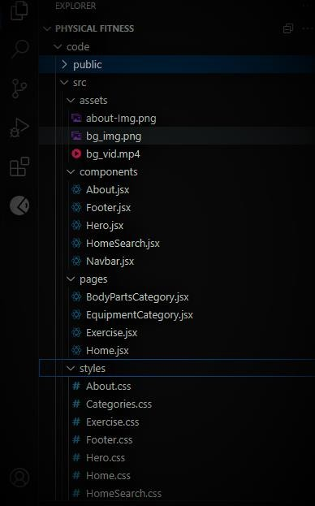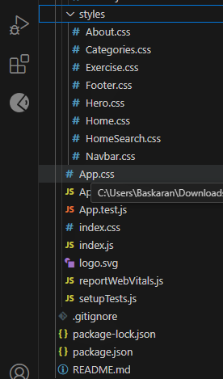

# screenshotsordemo:

**ProjectExecution:**

Aftercompletingthecode,runthereactapplicationbyusingthe command “npm start” or “npm run dev” if you are using vite.js

Herearesomeofthescreenshotsoftheapplication.

**Herocomponent**thissectionwouldshowcasetrendingworkouts or fitness challenges to grab users' attention.

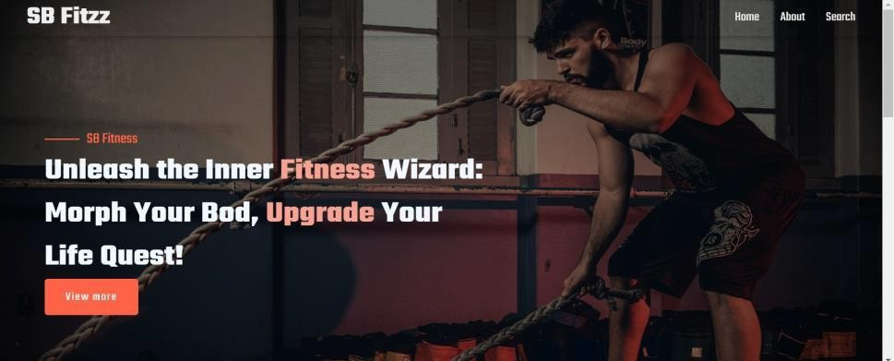

**About**

FitFlexisn'tjustanotherfitnessapp.We'remeticulouslydesigned to transform your workout experience, no matter your fitness background or goals.

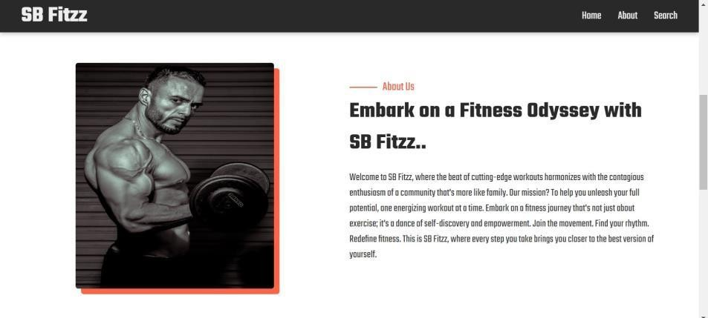

**Search**

B Fitzz makes finding your perfect workout effortless. Our prominent search bar empowers you to explore exercises by keyword,targetedmusclegroup,fitnesslevel,equipmentneeds,

oranyother relevant criteriayou have in mind.Simplytype in yoursearchtermandletFitFlexguideyoutotheidealworkout for your goals.

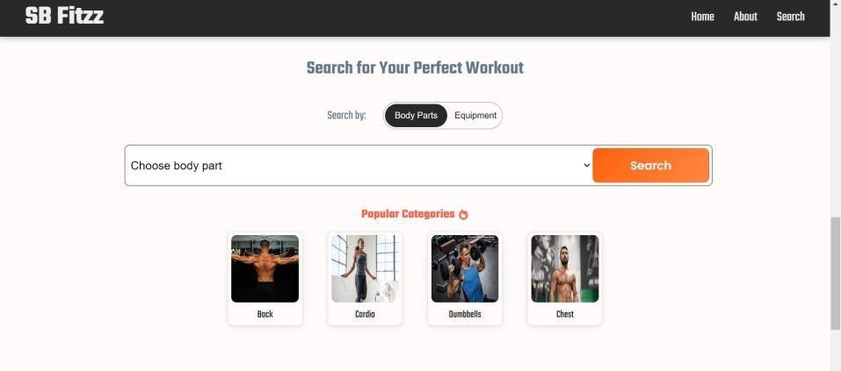

**Categorypage**

FitFlexwouldofferadedicatedsectionforbrowsingvarious workout categories. This could be a grid layout with tiles showcasing different exercise types (e.g., cardio, strength training, yoga) with icons or short descriptions for easy identification.

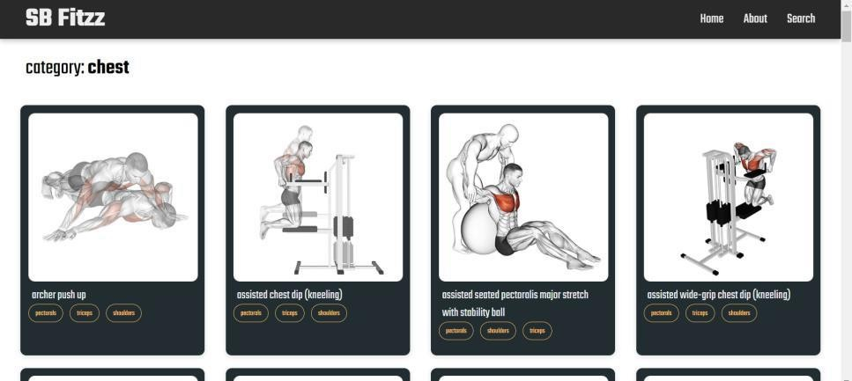

**Exercisepage**

This is where the magic happens!Each exercise page on FitFlex provides acomprehensiveoverview of thechosenworkout.Expect clear and concise instructions, accompanied by high-quality visuals likephotosorvideosdemonstratingproperform.Additionaldetails like targeted muscle groups, difficulty level, and equipment

requirements(ifany)willensureyouhavealltheinformation needed for a safe and effective workout.

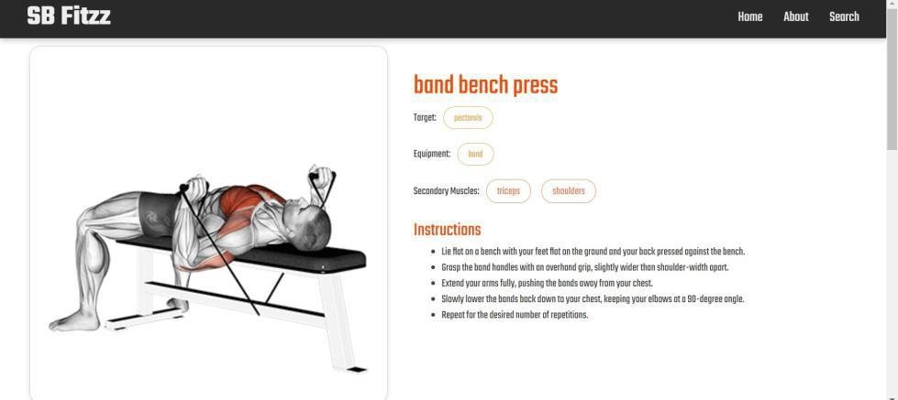



**13.knownissues:**

* **Operating System Compatibility**: Issues with compatibilityacrossdifferentoperatingsystems,suchas iOS or Android.
* **BrowserCompatibility:**Issueswithcompatibilityacross different browsers, such as Chrome or Safari.

## FutureEnhancement:

* + **AI-powered workout planning:** Use machinelearningtocreatepersonalizedworkout plans based on user goals, fitness level, and preferences.
  + **Customizable nutrition planning:** Allow userstoinputdietaryrestrictionsandpreferences to receive personalized nutrition plans.
  + **Virtualfitnessclasses**:Offervirtualfitness classes that allow users to work out with instructors and other users in real-time.
  + **Augmented reality workouts:** Create augmentedrealityworkoutsthat use 3Dmodels andanimationstoguideusersthroughexercises.

**THANKYOU**